## Introduction

The Oak Compact Joystick is a midsized joystick compatible with the XAC and PC. It has a range of toppers which can simply be press-fit onto the joystick and removed by pulling them off.

## Features

## A photo of the USB connection version of the Oak Compact Joystick, printed in green PLA and brown ABS.A photo of the topper options for this joystick printed in various colours of PLA.

## Usage

### Using the Joystick

1. Plug a USB-C to USB-A cable into the USB-C port on the joystick as shown above.
2. Plug the USB-A end of the cable into the host device (such as the Xbox Adaptive Controller).
3. Wait for joystick to initialize, approximately 15 seconds.
4. Ensure the arrow on the joystick is pointing in the “up” direction, away from the user.
5. Mount the device if needed (see below).
6. Move joystick as you would with a standard controller.

### Modifying the Dead Zone

The default dead zone of the joystick is set to 3 out of a maximum of 10. The larger the deadzone value, the further you can move the joystick without triggering any response. When plugged directly into a PC, the deadzone can be modified through the Arduino IDE serial monitor by the following commands:

1. Change the serial monitor output from “New Line” to “No Line Ending.”
2. Enter “SETTINGS” into the serial monitor. You should receive SUCCESS,0:SETTINGS
3. Enter “DZ,1,X” where X is a number from 0-10. 10 being the largest deadzone and 0 being no deadzone.
4. You must enter “SETTINGS” and receive SUCCESS,0:SETTINGS before entering “DZ…” every time.
5. If you enter “DZ,0:0” instead, you will receive the current deadzone reading.

### Compatibility

Compatible with the Xbox Adaptive Controller (XAC). May be compatible directly plugged into PC for some games.

This joystick is plug and play with the XAC and with PC, however will need additional switches for use without the XAC. Open source software such as [Vjoy](https://github.com/shauleiz/vJoy) and [Joystick Gremlin](http://whitemagic.github.io/JoystickGremlin/) can be used to combine switch inputs with the joystick.

### Changing the Joystick Topper

The toppers are installed and removed simply by pressing the joystick end into the hole in the topper.

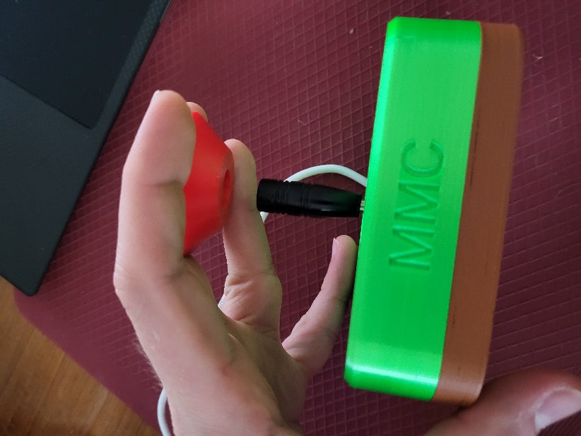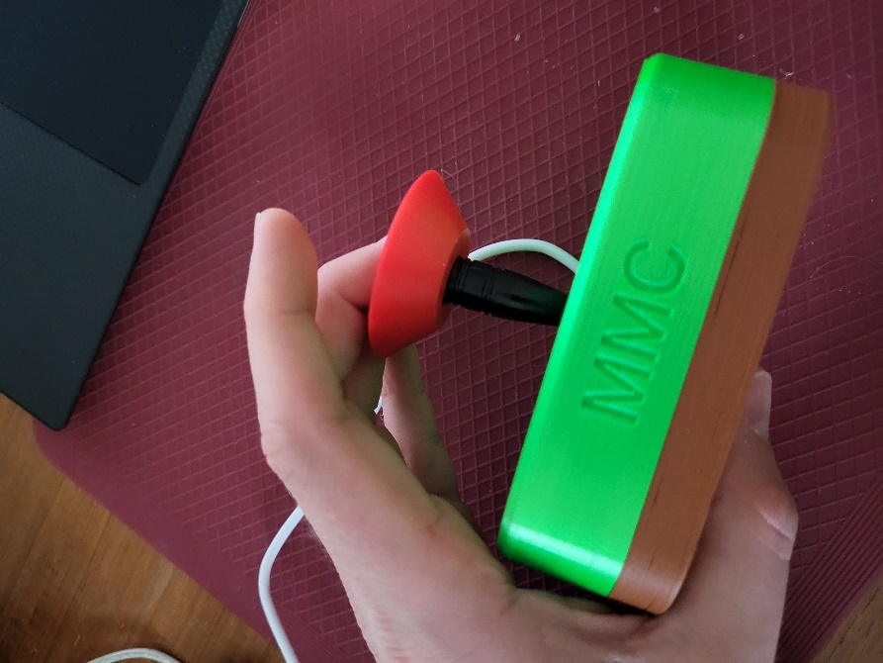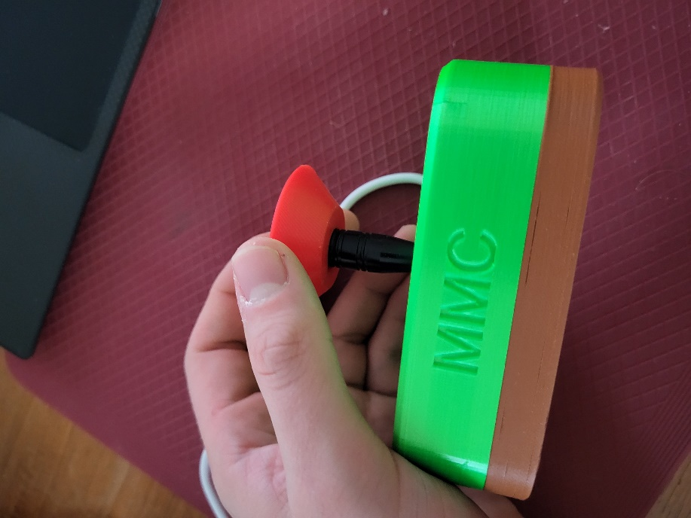

### Mounting the Joystick

The Oak Compact Joystick can be mounted using various methods, depending on your preference and how you can best access it.

**Note**: A different joystick is shown is the following mounting examples, but the same principles and methods will apply to this joystick.

#### Table Top Mounting – Non-Slip Pads

|  |  |
| --- | --- |
| If using the joystick on a tabletop, and height of the joystick is not a concern, nonslip pads can be added in each of the four corners on the bottom, as shown. |  |

#### Table Top Mounting – Hook and Loop Fastener

|  |  |
| --- | --- |
| If using the joystick on a tabletop or other surface with hook and loop fasteners, such as Velcro, stick the hook side (rough side) to the joystick and the loop side (soft side) to the surface to mount to. | Bottom of the joystick with hook and loop fastener attached to the bottom. The hook side is shown stuck to the joystick. |

#### Camera Mount

To mount the joystick on a camera mount, the optional Joystick Camera Mount Adapter can be used by simply screwing it to the bottom with two M3 screws.

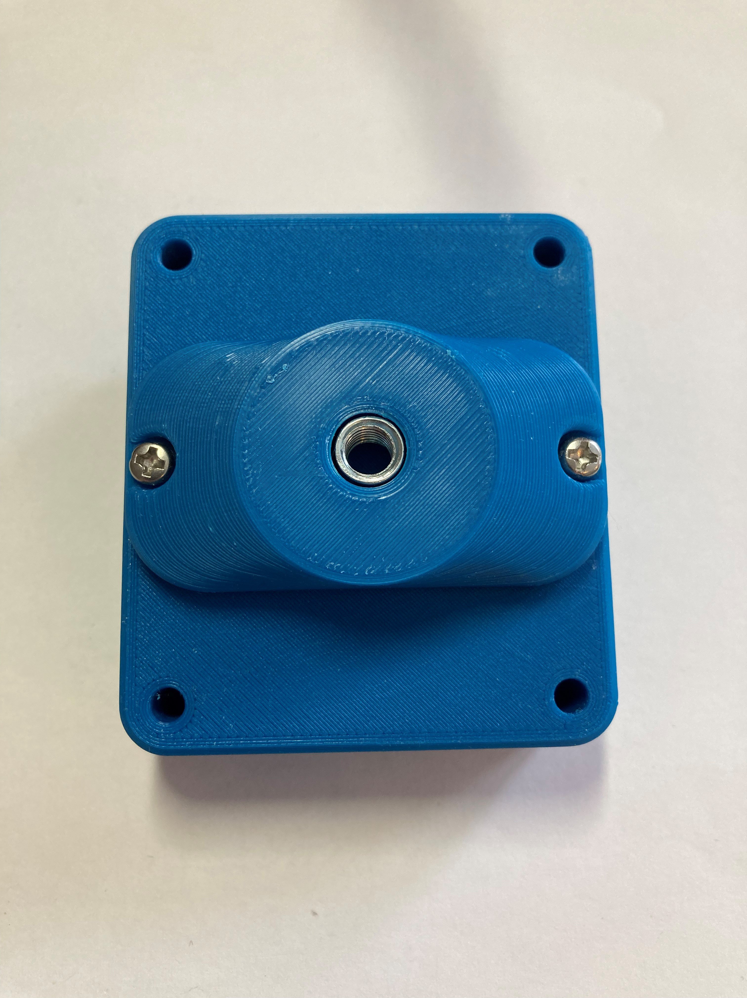

## Specifications

The joystick has a ±25° range of motion and takes approximately 525 grams of force to fully deflect.

|  |  |
| --- | --- |
| Total Height | 65mm |
| Enclosure Height | 34.4mm |
| Enclosure Width | 80mm |
| Enclosure Length | 106mm |
| Weight | 152 grams |

## Cleaning

Wipe the outside of the device with a lukewarm, damp cloth. Do not use hot water on this device or the plastic housing may warp. Do not submerge the device.